**Pyspark Assignment**

1. **Problem Statement: What is the daily product revenue for CLOSED or COMPLETE orders.**

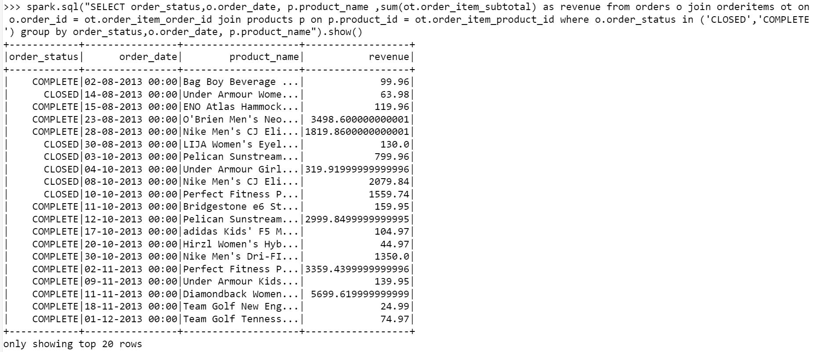

1. Load the required data in to DF like categories, customer,departments,order_items,orders and products.

**Order_item**

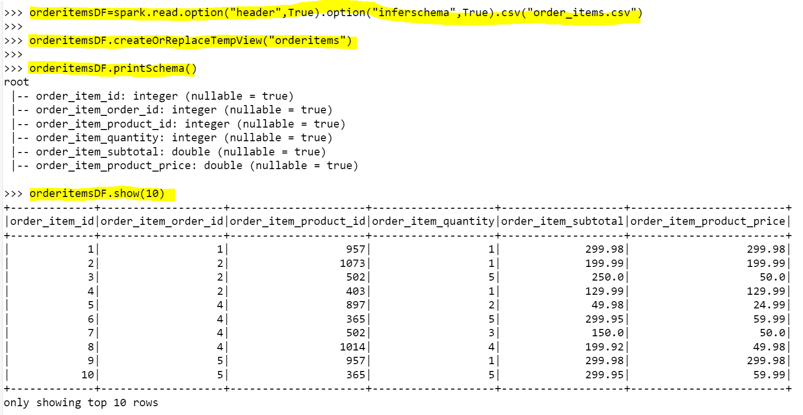

**Orders**

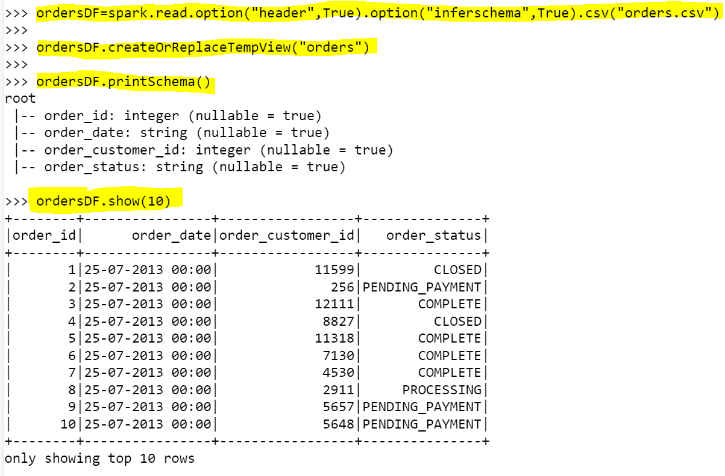

**Products**

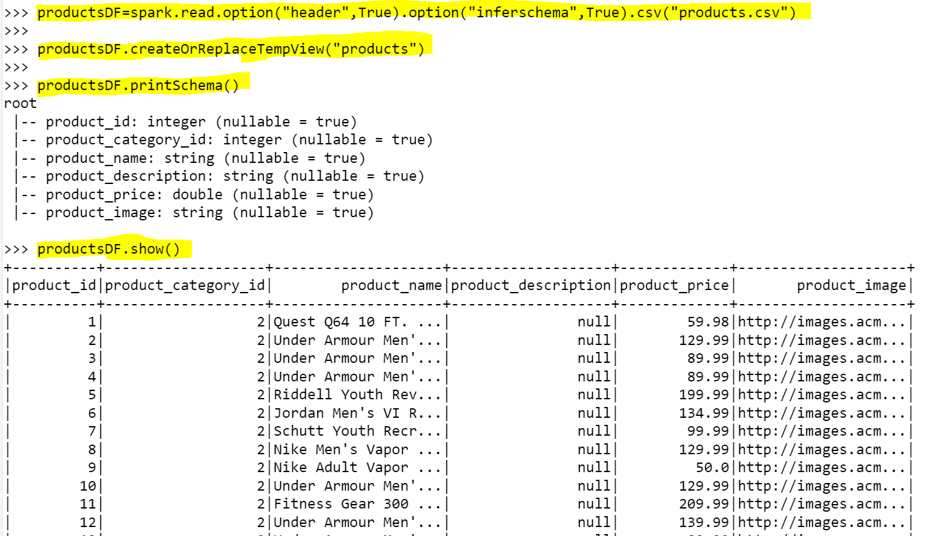

1. **Get the count for each order status**

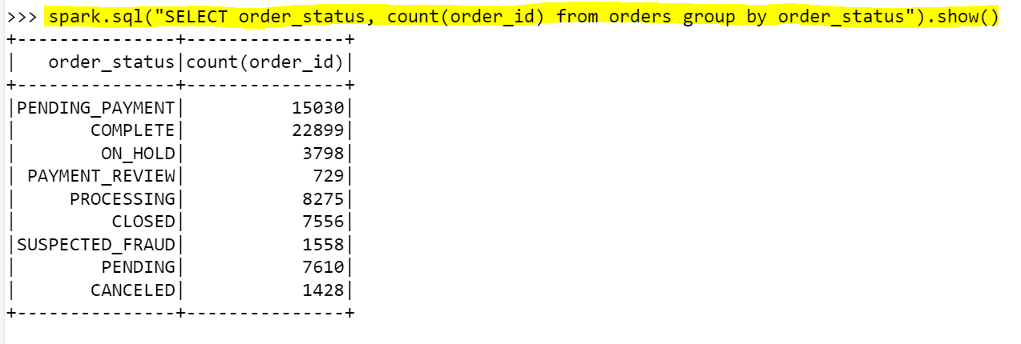

1. **Filter only COMPLETE or CLOSED orders.**

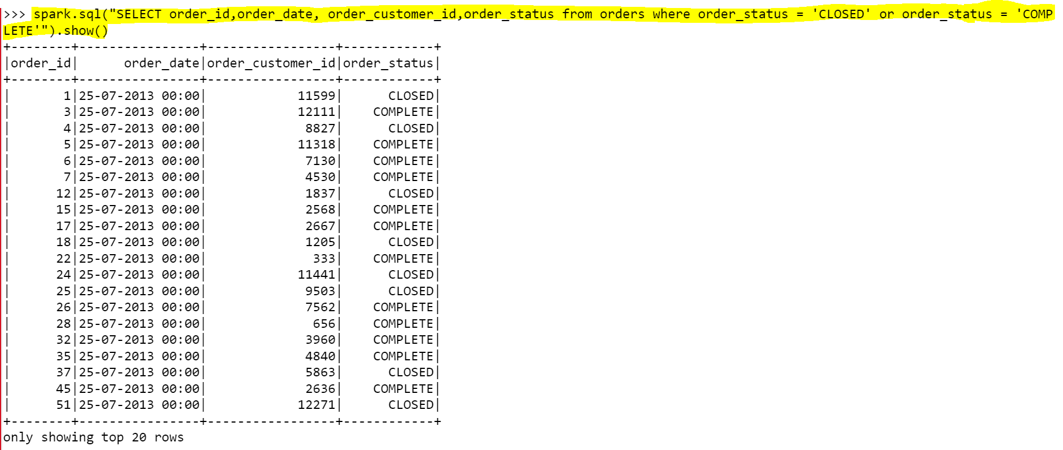

1. **Join the products , order_items and orders tables and calculate daily product revenue.**

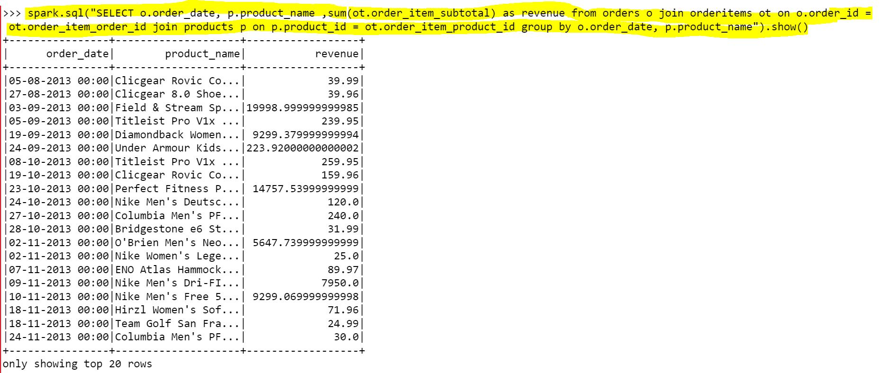

1. **Write the data in to the table Daily product revenue in Hive.**

